Restrictive (Essential) Appositive

🔹 What is Restrictive (Essential) Appositive?
# Source: AI Source: Provided by: [Data Path: Persons Table -> ID Column: 1, Name_En Column: Motasem Essam] -> From: [Chatgpt (GPT‑5 Mini)] on [8/7/2025]
A restrictive (essential) appositive is a noun or noun phrase that identifies or defines the noun it follows in a way that is essential to the meaning of the sentence.
It cannot be removed without altering the core meaning. No commas are used.

🔸 Key Features:
# Source: AI Source: Provided by: [Data Path: Persons Table -> ID Column: 1, Name_En Column: Motasem Essam] -> From: [Chatgpt (GPT‑5 Mini)] on [8/7/2025]
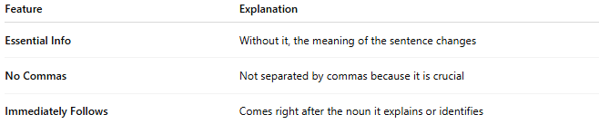
Feature | Explanation
Essential Info | Without it, the meaning of the sentence changes
No Commas | Not separated by commas because it is crucial
Immediately Follows | Comes right after the noun it explains or identifies

🔸 Examples:
# Source: AI Source: Provided by: [Data Path: Persons Table -> ID Column: 1, Name_En Column: Motasem Essam] -> From: [Chatgpt (GPT‑5 Mini)] on [8/7/2025]
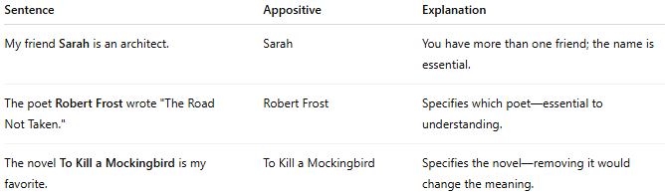
Sentence | Appositive | Explanation
My friend Sarah is an architect. | Sarah | You have more than one friend; the name is essential.
The poet Robert Frost wrote "The Road Not Taken." | Robert Frost | Specifies which poet—essential to understanding.
The novel To Kill a Mockingbird is my favorite. | To Kill a Mockingbird | Specifies the novel—removing it would change the meaning.

